Running the Demonstrator Modelling Framework

This repository at <https://github.com/robertworden/Covid-Modelling> contains a small demonstration Covid-19 modelling framework. You may examine or run the framework to illustrate the architectural issues described in the accompanying paper. This note contains instructions to run the framework on a Windows PC.

The runnable framework consists of two files:

* A java .jar file 'modeller.jar', which can be run by double-clicking it, or from a Windows command line
* A data file 'modelData.zip' which , when unzipped, contains the data files used to run a model.

Expand the zip file to a convenient location. The top folder is called 'COVID'.

Save the jar file in a convenient location, and double-click it to run it[1]. You will see a file choice dialogue. Navigate to the folder where you stored the unzipped 'COVID' folder, and open it:

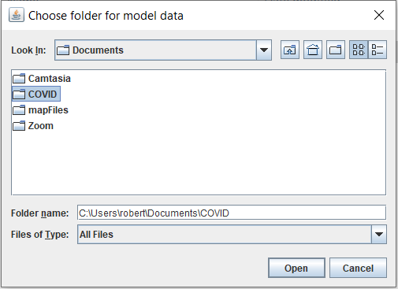

You will then see the main window of the modelling framework. It has seven tabs which you will see at the top left:

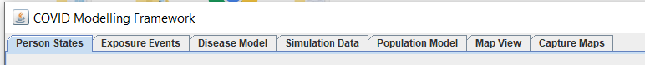

You can switch between these tabs to see what they look like, but they will not tell you much yet, as the program has only loaded a small amount of driving data at this stage.

To run a model of Covid-19 spread, you first need to read in (or create) a demographic model - a set of households, people and meeting places, together with the meetings between people that would take place in the absence of controls. A model is in the data folder, and you can read it by pressing the 'read model' button shown.

It takes about a second to read the data, and shows that the modelled population is about 1700 people:

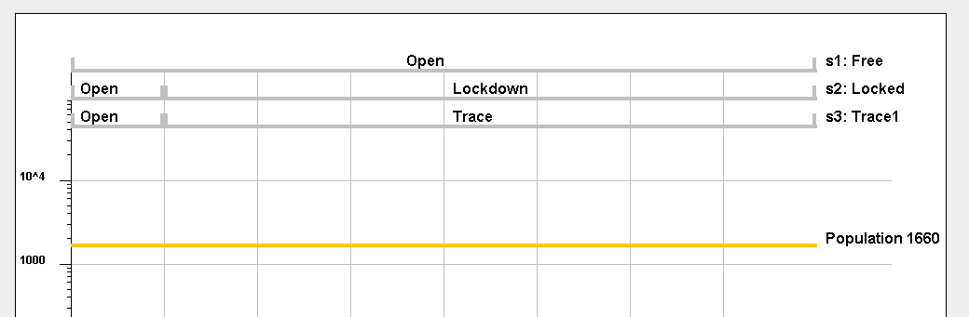

This small population has been used to make the demonstrations run quickly.

The 'run model' button is now enabled, to run the model in the three scenarios shown above (doing 5 runs per scenario, to probe the level of random variation). The simulation runs in a few seconds.

Having run a simulation, you can inspect the results in a range of graphs and plots on the different tabs. Dropdown menu boxes on the tabs set the parameters of the plots.

To show a typical graph - the number of people who have had Covid-19 and recovered, in the lockdown scenario - do the following:

* In the 'scenario' dropdown, select the scenario 'locked'
* In the 'disease state' dropdown, select 'immune'
* In the 'colour' dropdown, select 'blue'
* Press the 'add plot' button and you will see:

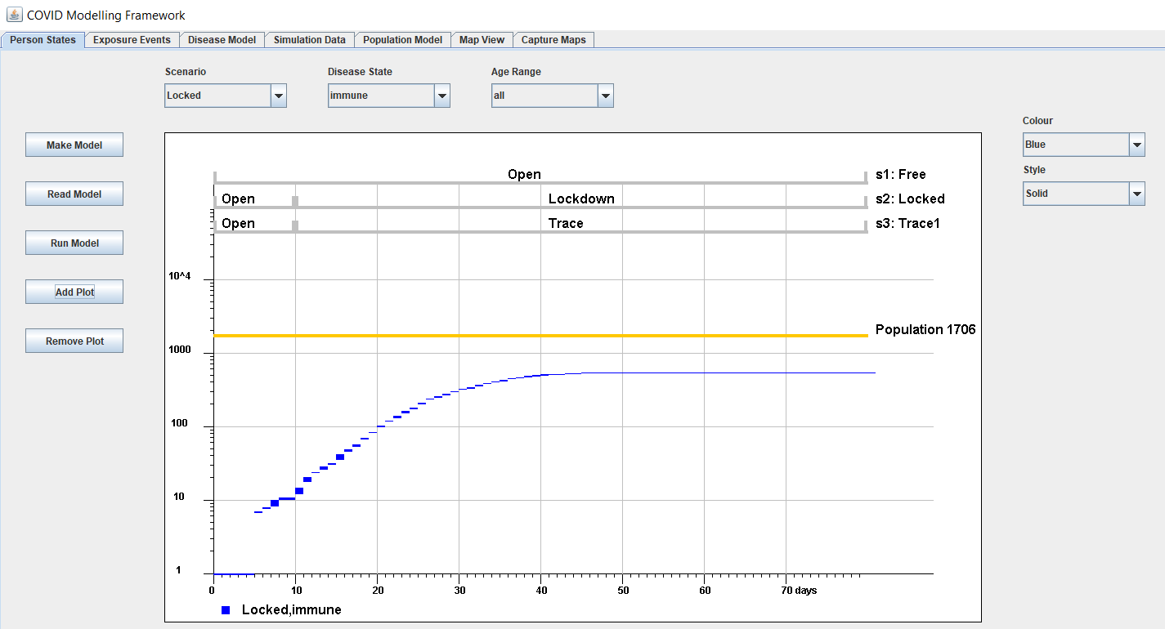

While the blue bars appear to come close to the total simulated population after 40 days, because it is a log plot, the difference is actually about a factor 5.

The width of the blue bars shows the range of uncertainty (between upper and lower quartiles) in the different runs of the model with identical parameters and identical start data.

You can add further graphs for comparison, without removing existing graphs. You can add or remove graphs to a stack of graphs using the 'add plot' and 'remove plot' buttons. In this way you can quickly try out graphs and refine them or remove them if they are not what you want.

The graphs on the first tab show numbers of simulated people in different states.

The second tab 'Exposure Events' shows numbers of meetings in which people were exposed to the disease. For instance you can show the number of people exposed in their homes, compared to those exposed in public places. Using similar dropdown choices as in the first tab, you can show graphs like:

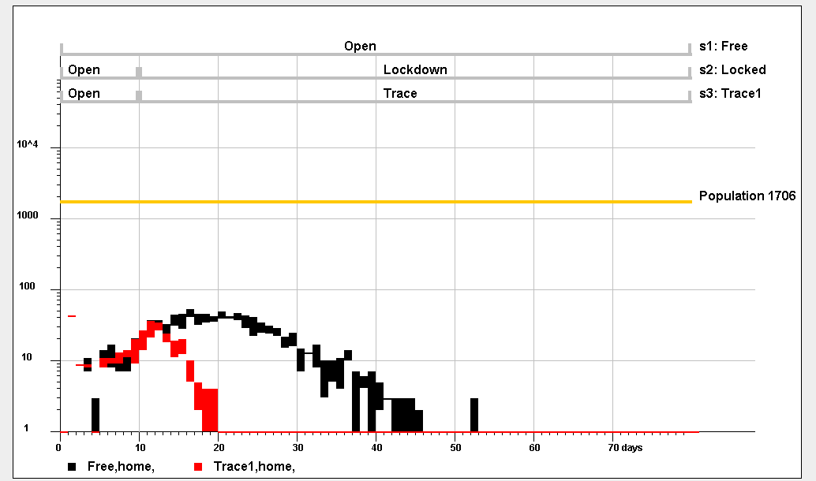

This graph shows a fairly rapid effect of contact tracing on numbers of people infected at home (all these graphs use arbitrary parameters which were chosen only to exercise the framework; results have no validity without choosing realistic parameters and carefully checking outputs for sense).

You may also display results in the 'Disease Model' and 'Map View' tabs. The 'disease model' tab shows the progression of the disease in simulated people, as a function of the number of days after they were exposed to the disease. On this tab, you can check the consistency between theoretical probability calculations and the Monte Carlo simulation results:

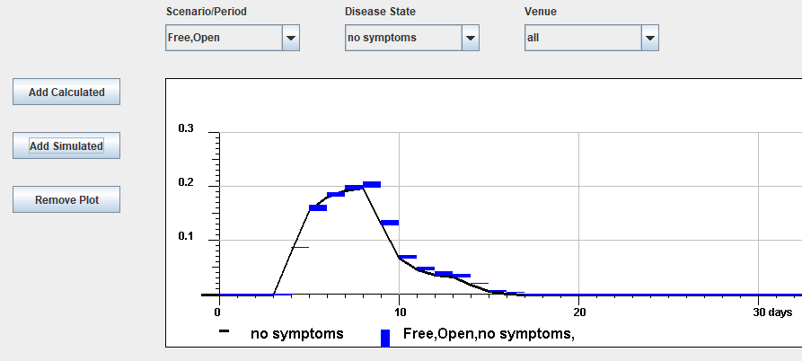

The black and blue graphs are the calculated and simulated results respectively. They should be the same within the error bars.

The 'Capture map' tab is used to capture region polygons from maps. Currently it can only capture maps of the UK from the Office of National Statistics in KML files.

If you wish to run models with altered parameters, it is worth understanding what the parameters mean, by looking at the 'Simulation Data' tab. Each model is driven by a number of csv files, which are in sub-folders of the 'COVID' folder. The Simulation Data tab enables you to choose any file to see its contents , with an explanation of what the contents mean.

For instance, a file which determines overall running parameters of the running models is the file Parameters.csv, which you can inspect as follows:

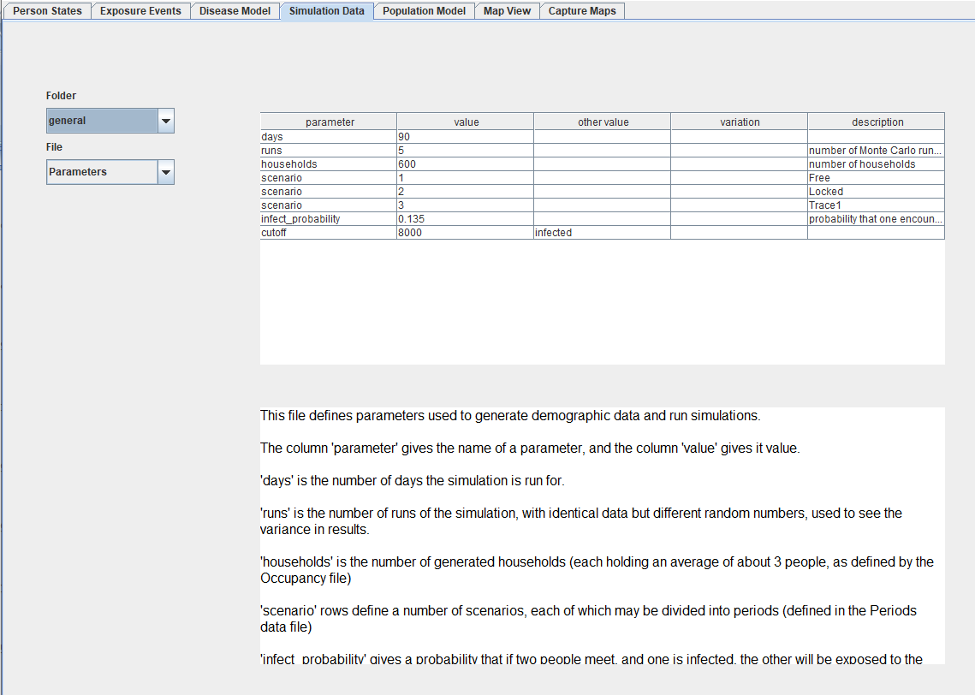

You can edit the driving files in their folders and re-run the model. If you run models with larger populations , it will take longer, and you may need more memory.

The 'population model' tab shows the files of generated demographic data, which are input to the simulation runs.

1. Running a .jar file by double-clicking it does not allow the program to use extra memory. If you need to run larger models than that provided in the demonstration data folder, you may need to request extra memory for the program, by including a string like ' -Xmx4096M ' in the command line to run the program. The program has a main class cMain.java, also needed in the command line.